DAY 17: Create Alerts and Dashboards in Kibana

Understanding Logon Types in Windows Login Event

Logon Type 7 - Unlock (Unlock screen)
- Occurs when a user unlock a locked workstation - for example: machine is locking the screen (Windows + L), then a user back and type the password to unlock.
- This is not a newly login session, but this is an existing session and just unlock again.
- Usually take place in-place (local) - user sit in front of the machine.
For example: An Employee has lunch, locks the screen. After they finish and back to the machine and enter the password to unlock → Generate Event 4624 with Logon Type = 7.

Logon Type 10 - RemoteInteractive (Remote login over network)
- Occurs when a user login remotely through terminal services / RDP.
- This is an interactive login over the network, and does not sit in front of the machine.
- Specially designed to distinguish Login Type 3 (normal network logon, e.g. access file share service). Type 10 is dedicated to working sessions that have a remote graphical interface.
For example: An admin IT is home, using Remote Desktop Connection to connect to the company server -> Generate Event ID 4624 with Logon Type = 10.

Core Difference: Has Graphical Interface or Not
Criterias | Type 3 (Network) | Type 10 (RemoteInteractive)
Bản chất | Login over network to access resources ( shared file / folder, pipe...) | Login over network to get a full Graphical User Interface working session.
GUI | No GUI, No Desktop | Full GUI with mouse interaction, identical to sitting at a physical machine.
Typical Protocols | SMB (access \\server\share), NTLM/Kerberos background authentication. | RDP (Remote Desktop Protocol), Terminal Services
Behaviors Example | Opening files on network drives, accessing Admin$ share, PsExec (in background), using certain pass-the-hash tools. | Opening Remote Desktop Connection (mstsc.exe) to control a machine remotely
Session duration | Extremely short, connects and disconnects instantly. | Persistent, maintains connection throughout a session.
Significance in DFIR | Suspicious Activities: Covert lateral movement (using PsExec, WMI, pass-the-hash) and unauthorized share access. | Suspicious Activities: RDP brute-force, remote hijacking.

Logon type 3 scenarios:

The following methods can be used to generate these events:
Method A: Accessing a file share
- On target machine, share a folder: right-click→ Properties → Sharing → Share
- From source machine, open File Explorer and type: \\<IP-target>\<share-name>
- Enter credential when prompted → Successfully accessed
- Verify Event Viewer on Target → Event ID 4624, Logon Type = 3
Method B: Using net use (command line, quick and easy)
From a source machine, open CMD and type:
cmd:
net use \\<IP-target>\IPC$ /user:<username> <password>

→ This command establishes a network connection to the target → triggering Event 4624 with Logon Type 3 on the target machine.
Method C: Using PsExec (simulate lateral movement, a common scenario encountered in pentest/DFIR lab)
cmd:
psexec \\<IP-target> -u <username> -p <password> cmd

→ Beside of type 3, there is other logon type. Refer to the link at [1] to improve analyzing capability skills.

Now, go back to the lesson today. I will create a map widget and statistical table to gather events related to both successful and failed RDP logins into the central point to get an overview of what is happening in my network.

First, I will search for successful RDP login events with logon type 7 and 10 is Unlock or RemoteInteractive. So the fields that are specified as search bar in Figure 1.
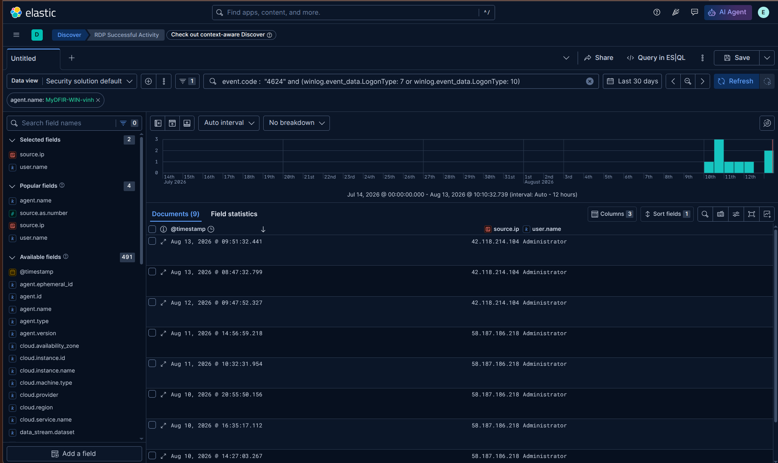
Figure 1: Create a discover session for Successful RDP login
At the time I’m searching, the number of matching documents is 9. Read more information in the message field to verify that the query search works fine and understand other information.
Go to Dashboards page and create a map as DAY 14 for RDP Authentication Activities, copy and paste above query into Query Section:
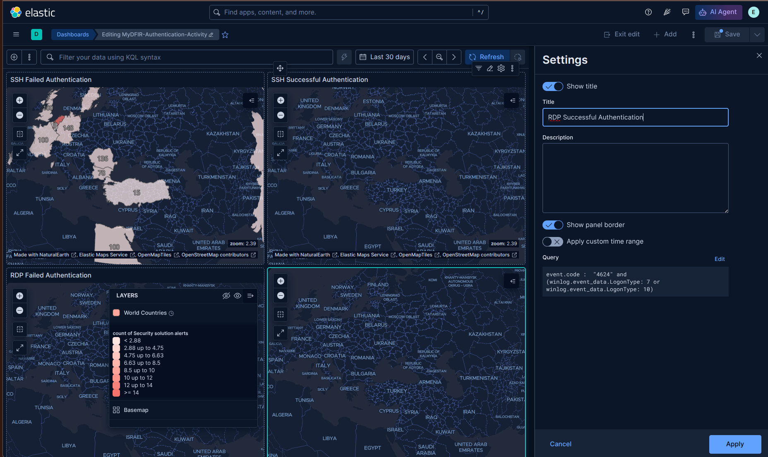
Figure 2: Create dashboard widgets for both successful and failed RDP login

Change the time filter to last 7 days, and all map widgets will automatically update to search for events within last 7 days:
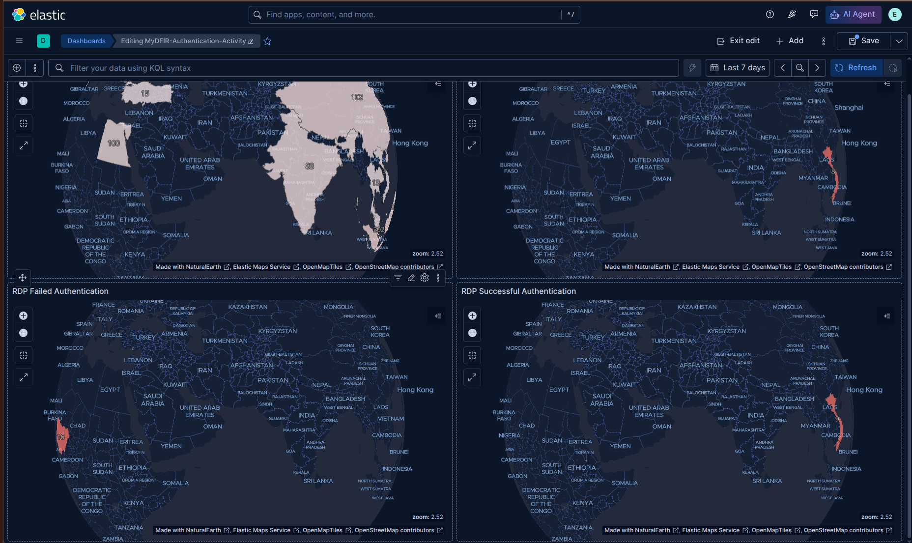
Figure 3: Dashboard display statistic login data within last 7 days
As you can see in Figure 3, RDP authentication activities mainly focus on VietNam.

Finally, I will create visualization in table form for each activity:
I choose 3 fields: user.name, source.ip and source.geo.country_name as a main field to investigate easier. The final column will display count of records corresponding to each 3 tuple. The number of values parameters will set for individual field column. As you can see, user.name field’s Number of values is specified 10, it means maximum unique values it count is 10 (e.g., root, admin, user1,...), if it detect value 11, it will displays “Other” and not actual value of that cell.
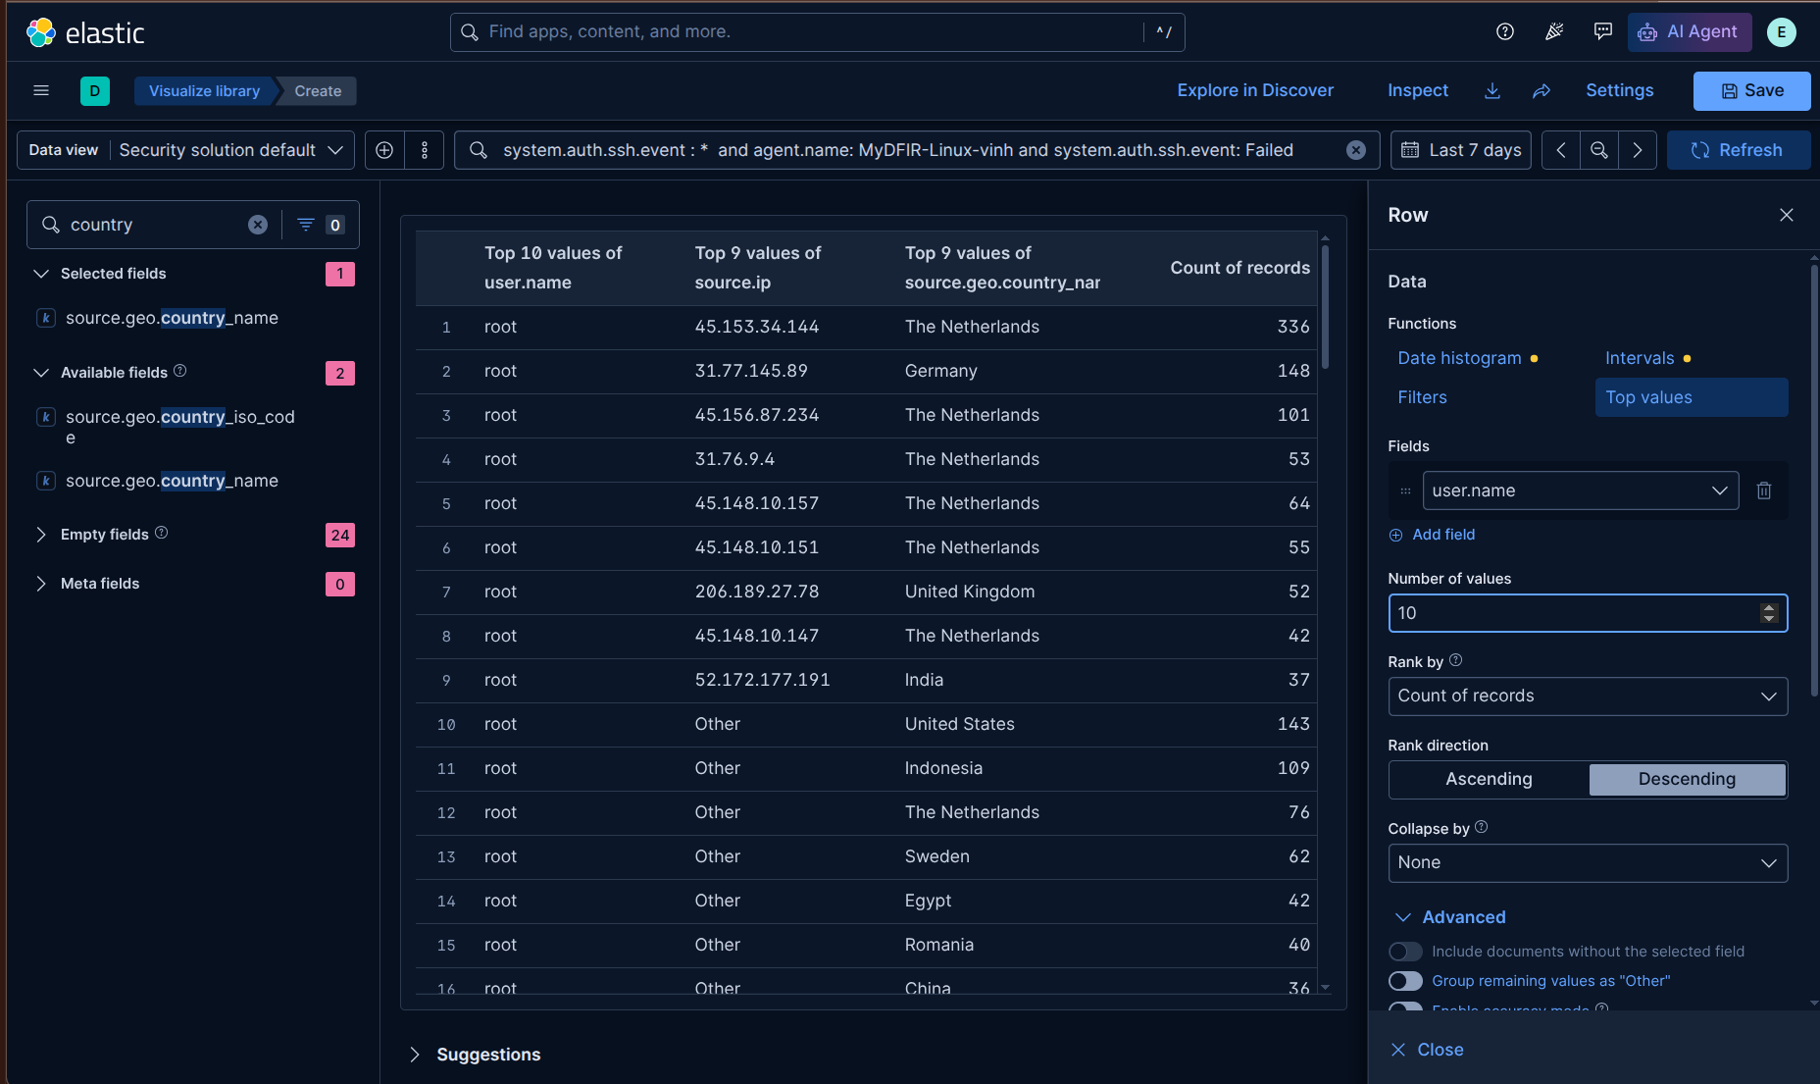
Figure 4: statistical table for failed SSH authentication
Next, I will sort rows by “count of records” in descending order: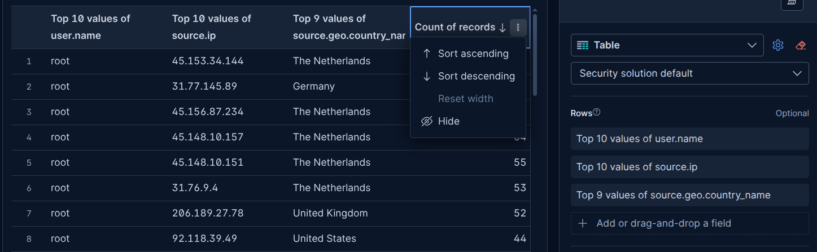
Figure 5: Sort rows in descending order by “Count of records” column
Now, we can begin to investigate by identifying source IP addresses that appears most frequently at the top of the table. We can then check its reputation using blacklist databases to determine whether it is associated with known malicious activities.

Adding more 2 table for both successful and failed RDP login activities in below:
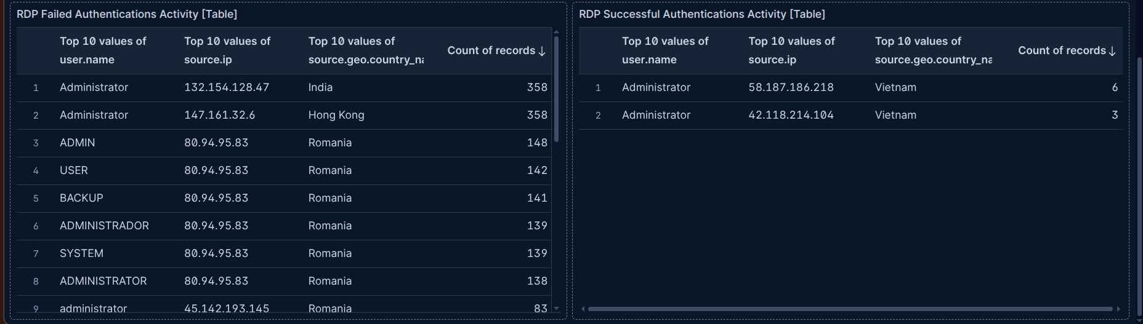
Figure 6: statistical table for both failed and successful RDP logins

REFERENCES:
[1] Understanding Authentication and Logon:
https://www.ultimatewindowssecurity.com/securitylog/book/page.aspx?spid=chapter3
[2]

